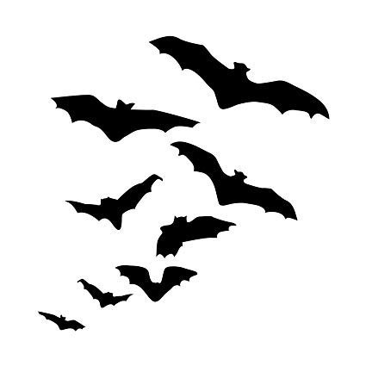Fundraising Makes It Happen at
Canadian Martyrs’ Catholic School

Dear Families,
We are hosting our school wide annual Dance-A-Thon Fundraiser on Thursday October 31st, 2019 for all students. The theme is “Halloween Black and Orange”. This year the Community Council has agreed to continue to dedicate itself to only two major fundraisers with this being the first one. The Dance-A-Thon is lots of fun for the students and we need your help to make this happen.
All money raised by the dance-a-thon go directly to your child’s educational life. Here are some examples of where the funds have been spent in the last few years: Classroom Smartboards, Chromebooks, Team jerseys, mascot murals, sports equipment, and athletic/tournament fees.
We do not encourage students to go door to door without an adult, but please ask your family and friends for sponsorship. Attached you will find an envelope and sponsor sheet. Thanksgiving is a terrific time to gather pledges from family and friends. Pledges and money are due back to the teachers by Thursday October 24th, 2019 so that students’ names can be entered into the draw.
Incentive Prizes:
JK to Grade 2 Students – Primary Games Gift Basket
Grade 3 to Grade 5 Students – Board Game Gift Basket
Grade 6 to Grade 8 students – Movie Night Gift Basket
For each five dollars your child is sponsored, his/her name will be placed on a ballot for the incentive price. Good Luck!
Thank you in advance for your participation!
Members of Canadian Martyrs’ Catholic Community Council 