Canadian Martyrs – Newsletter
September 20, 2019

Today’s newsletter contains the most current and updated information. Please read below:

School Messenger

We are excited to announce that the Simcoe Muskoka Catholic District School Board is implementing a new communication system that will enable us to contact parents and guardians quickly and easily via email, text message and/or voice callout. This system will be used to deliver timely information to families, especially in an emergency situation. It will also be used to provide you with important updates about what is happening in the Canadian Martyrs Catholic school community.

In order for this tool to be successful we must have your most up-to-date and accurate contact information on file in our office - this includes home phone, email and cell phone for anyone who should be receiving communication for your child. Please carefully review the Student Verification Form that was sent home with your child this week. Changes and updates should be indicated on the form and returned to the school as soon as possible.

In addition, you will be required to Opt-In in order to receive text messages. You can choose to pre opt-in by following the instructions on the School Messenger Opt-In Flyer or alternatively a message will be sent to your cell phone by the end of September and by choosing “Y” you will automatically be added to our system to receive text messages.

Click here to access the Opt-In Flyer

Thank you in advance for helping us improve communication within the Canadian Martyrs Catholic school community.

Picture Day – Tuesday, September 24th
This is just a reminder that Picture Day will be Tuesday, September 24th.

Pizza Q/Open House – Thursday, September 26th 5-7pm
This is just a reminder for families to place their orders for food through school day or they can use the order form attached. Click here for the Order Form

PA Day – Friday, September 27th
Click here to see the agenda

Terry Fox Run/Walk – Friday, September 20th

Canadian Martyrs students and staff participated in our 18th annual Tery Fox Run/Walk. The weather cooperated and we were able to exceed our goal of raising $500. We are pleased to announce that we exceeded our goal and were able to raise $865.02. Thank you so much for your generosity and support for such a worthy cause.

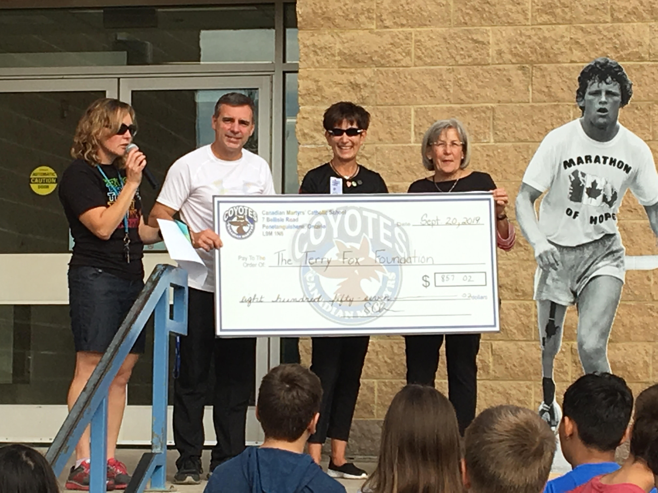

Smile Cookie Campaign - GBGH – Friday, September 20th

Today we had a visit from Wicks and The Dock FM crew who delivered Smile Cookies for the entire school thanks to the generousity of our wonderful Parent Council. A cheque for $260 was given with the proceeds to go directly to Georgian Bay General Hospital.
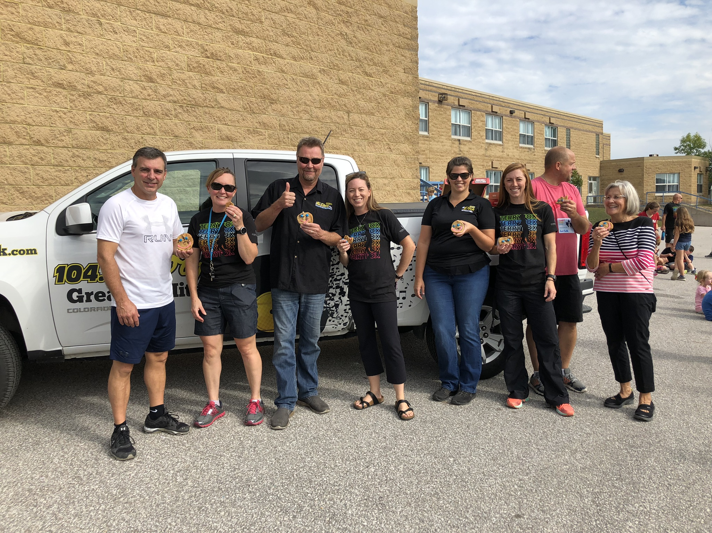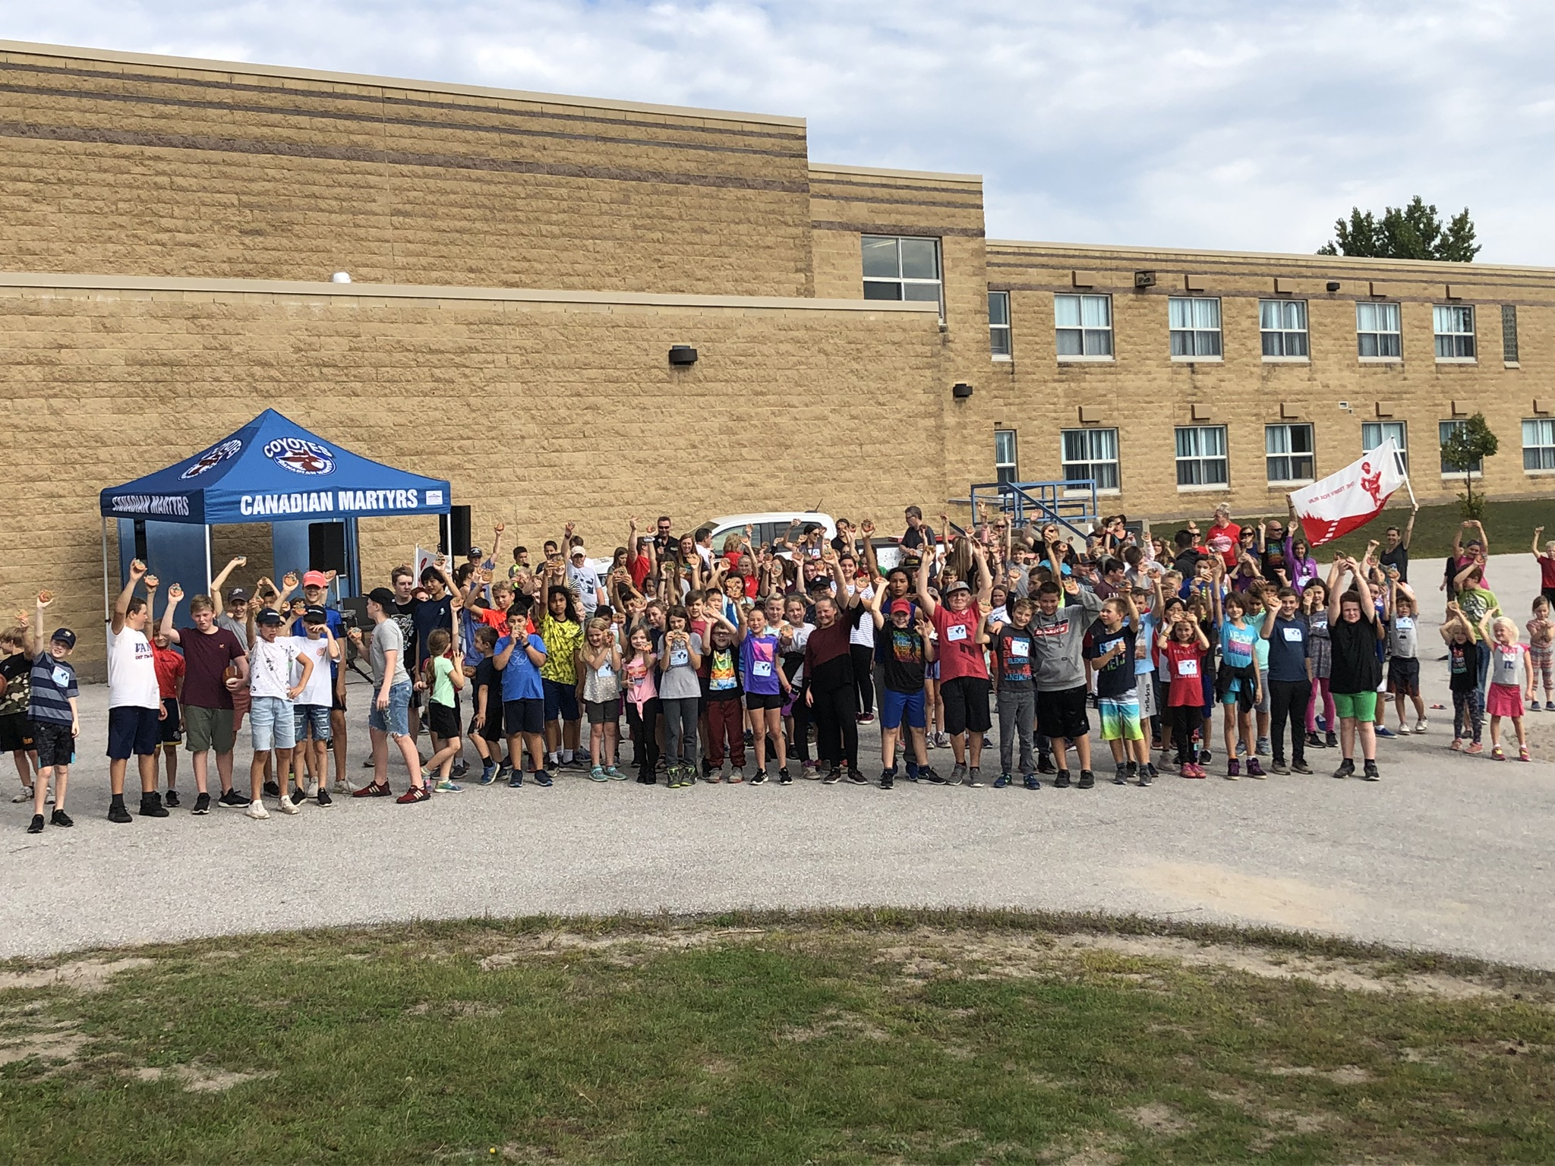

Orange Shirt Day – Monday September 30th

Orange Shirt Day is a legacy of the St. Joseph Mission residential school commemoration event held in Williams Lake in the spring of 2013. It grew out of Phyllis’s account of losing her shiny new orange shirt on her first day of school at the Mission, and it has become an opportunity to keep the discussion on all aspects of residential schools happening annually. The date was chosen because children are back in school and teachers have time to plan, and because it is an opportunity to set the stage for anti-racism and anti-bullying policies for the year. Orange Shirt Day is also an opportunity for First Nations, local governments, schools and community agencies to come together in the spirit of reconciliation and hope for generations of children to come.

We at Canadian Martyrs are asking students and staff to wear orange shirt on September 30th.

Please visit the following link for more information regarding Orange Shirt Day. http://www.orangeshirtday.org/

Staffing Changes

I’d like to take this opportunity to congraulate Mrs. Ashley Bowen as she begins in her new role at the Board office as a Math Coach beginning Monday, September 23, 2019. I would also like to welcome Ms. Krista Gurney as she now take on the role of the grade 4/5 teacher.
We are also excited to annouce that we have granted permission to hire one more Educational Assistant. Mrs. Krystal Mount joined us this past Monday, September 16th.

Milk Bags Wanted
The Canadian Martyrs Grade 7 and 8 Girls will be collecting milk bags to make sleeping mats. The milk bag mats offer people without beds, an invaluable, durable and washable alternative to sleeping on the often cold and damp ground. Not only can these milk-bag mats provide comfort as a bedding alternative, but have been used by health-care professionals as a make-ready substitute for an operating bed/table where resources are scarce. It takes approximately 400 milk bags to make an adult sized mat. Once mats have been made the girls will donate them to the homeless in Canada and support other countries when natural disasters occur. Please help by dropping your clean milk bags off at the school in the bins provided. Thank you for your help!

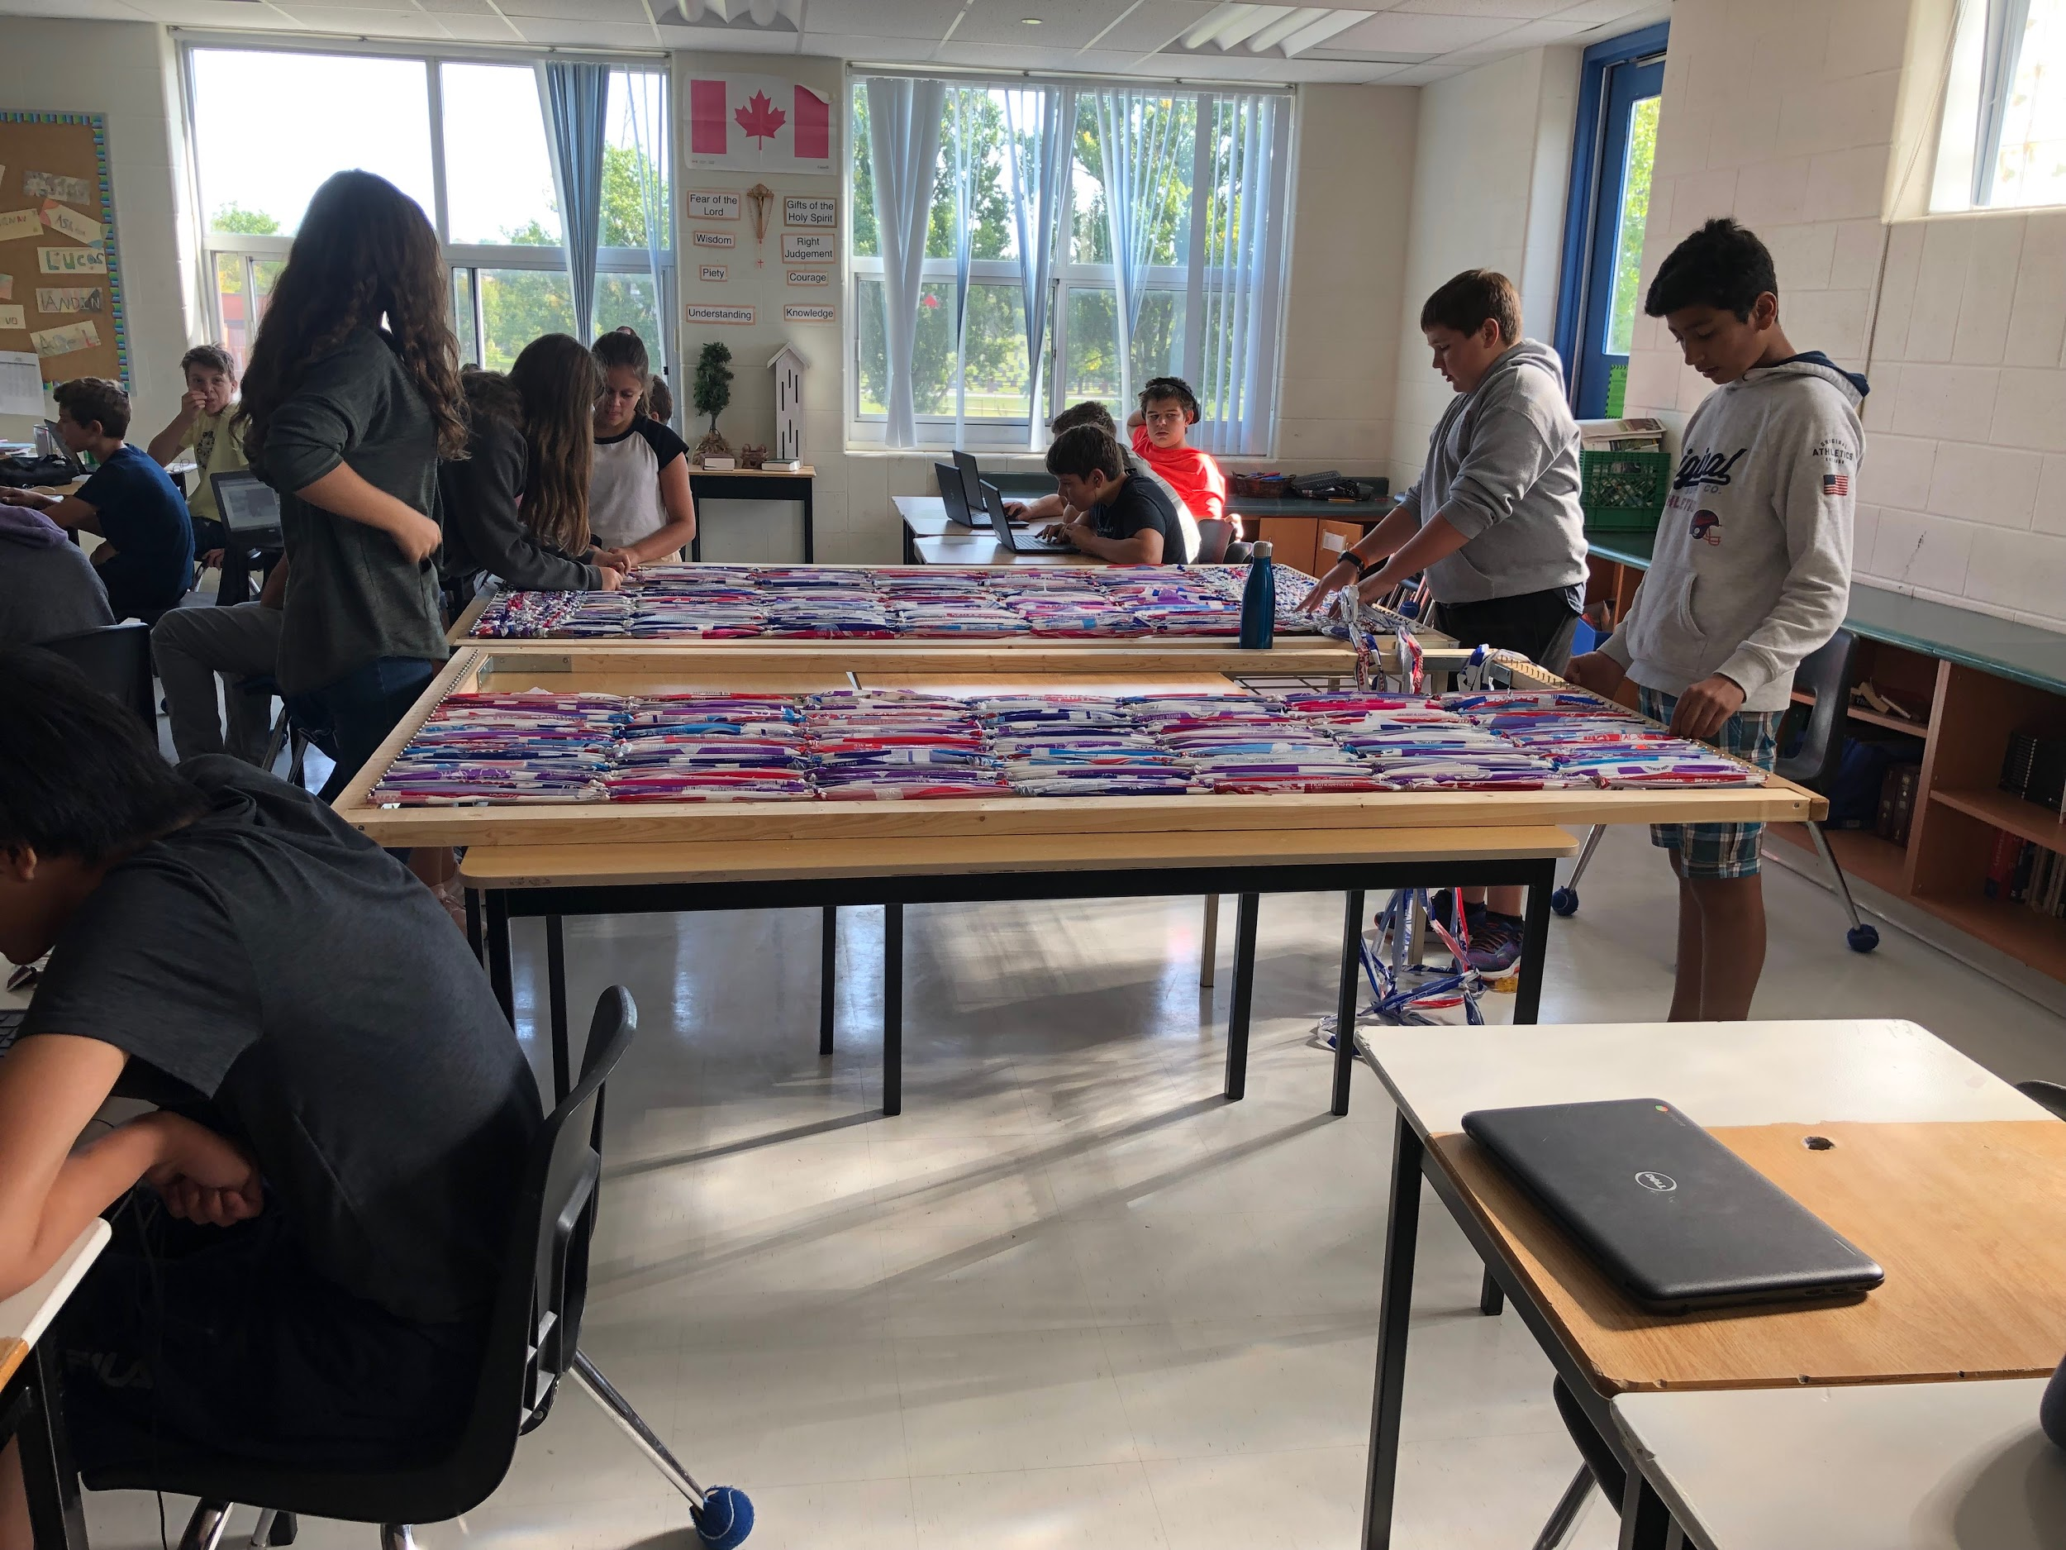
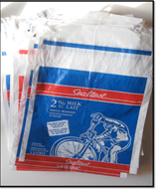
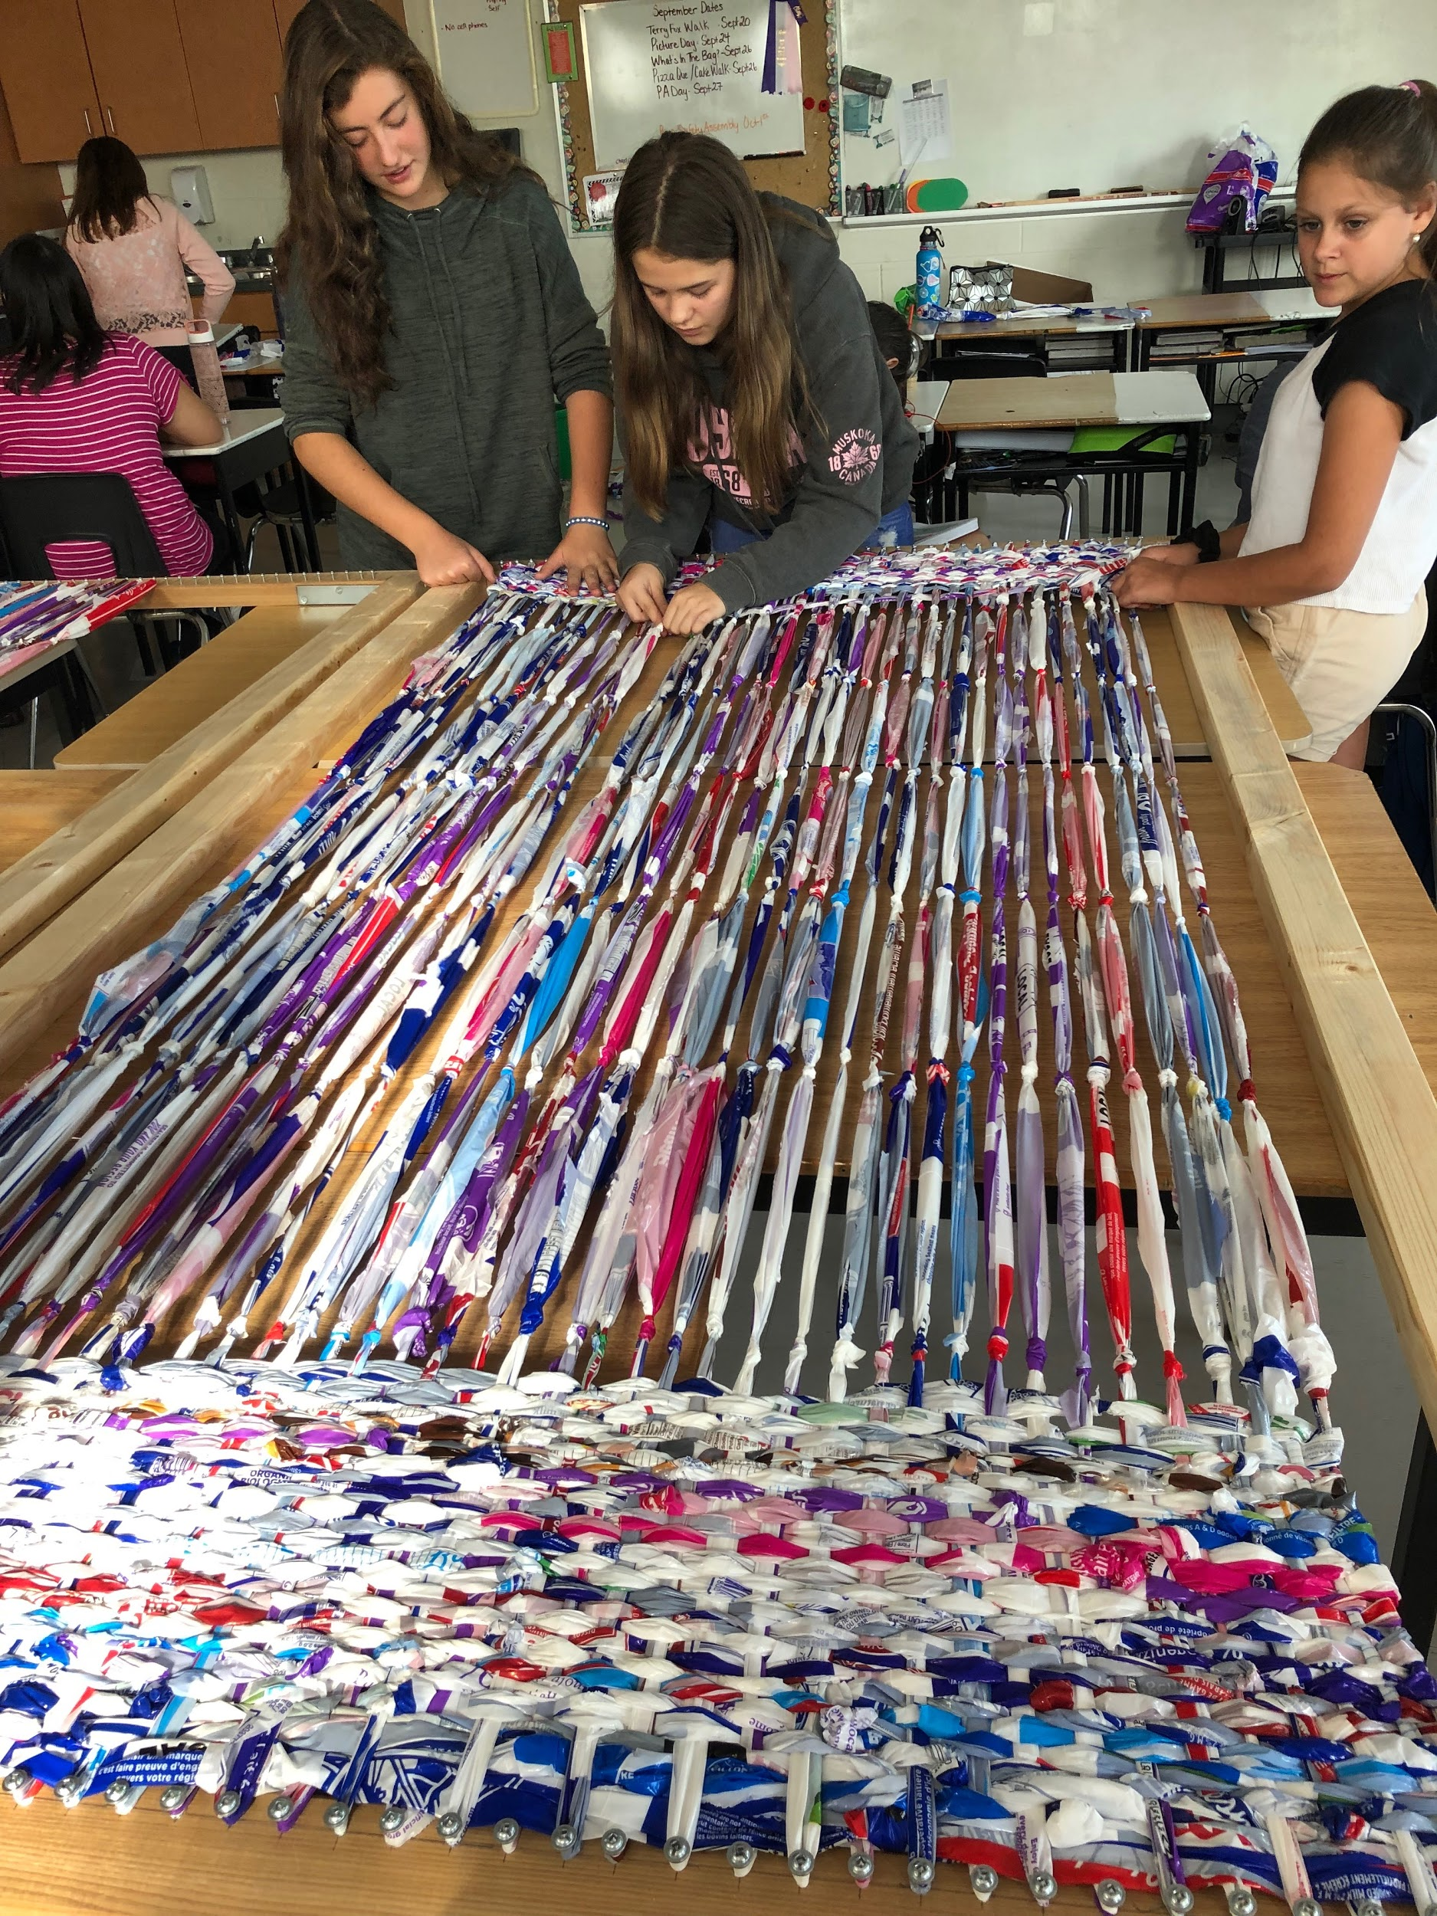

Pizza and Milk Orders
Monthly pizza and milk orders will begin on October 1st. Please use School Day to place your orders.

SMCDSB Strategic Plan: Click here for more information regarding the survey.

